**Design Document**

**Team:** CSM #2

**Project:** Machine Shop Electronic Access/Inventory System

**Client:** Dr. Kevin Moore

**Current Design Issues**

* Accessing a Mines database that contains information about students (which can be extracted given their CWID) has been a roadblock so far. The only information we are concerned about is name, e-mail address, and whether the person is a current student at Mines. Currently we are working on an API to connect to a pseudo Oracle Database that will be sent to CCIT for verification before proceeding.
* As of yet we do not have a dedicated space on a server on the Mines network to host our MongoDB instance that will be storing all of the persisted data for our project. We are waiting for CCIT to approve our request.
* All of the other issues we have run into, such as how to query the MongoDB instance and translate JSON into Java, have been solved by researching online.

**Software**

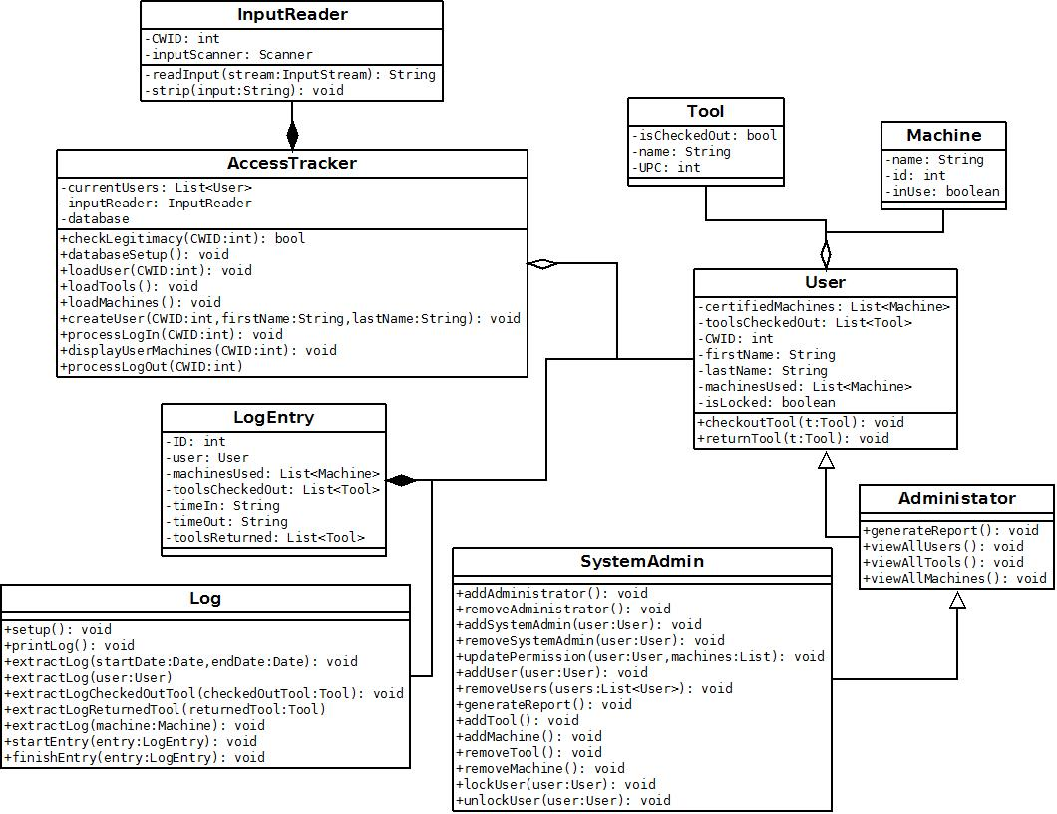

**Machine Shop Database (Mongo DB)**

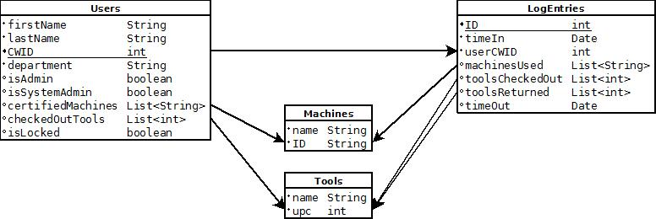

**Mines Database Design (Oracle)**

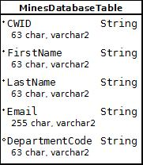

**Overall System**

